Results

1. Case 1

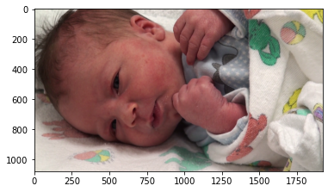

Pain = 0.6117376130898713%

No pain = 99.38826238691014%

The predicted image is : No pain

Accuracy poly: 1.0

Average precision-recall score: 1.0000

poly Accuracy : 1.0

poly Sensitivity : 1.0

poly Specificity : 1.0

F1 Score Poly: 1.000

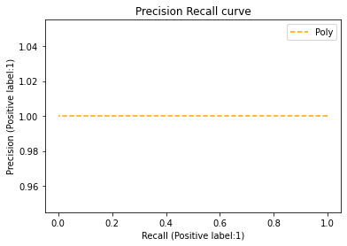

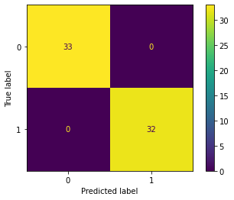

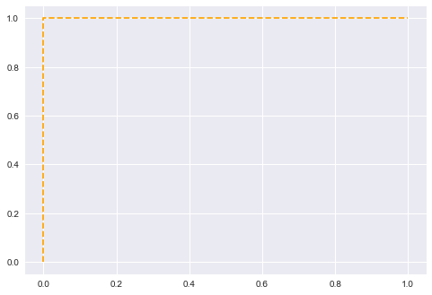

1. Case 2



The model is 100.0% accurate

Pain = 40.86878025767766%

No pain = 59.13121974232235%

The predicted image is : No pain

Accuracy poly: 1.0

Average precision-recall score: 1.0000

poly Accuracy : 1.0

poly Sensitivity : 1.0

poly Specificity : 1.0

F1 Score Poly: 1.000



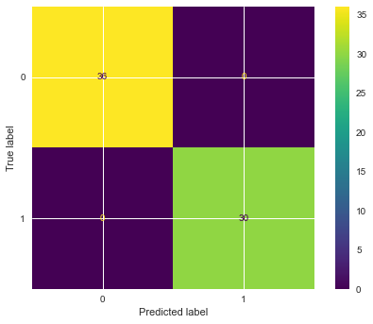 



1. Case 3

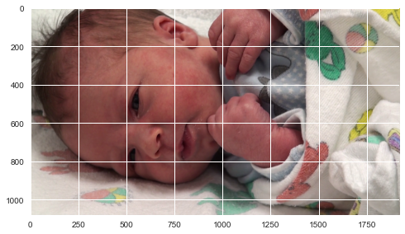

The model is 100.0% accurate

Pain = 1.3107302002727517%

No pain = 98.68926979972726%

The predicted image is : No pain

Accuracy poly: 1.0

Average precision-recall score: 1.0000

poly Accuracy : 1.0

poly Sensitivity : 1.0

poly Specificity : 1.0

F1 Score Poly: 1.000

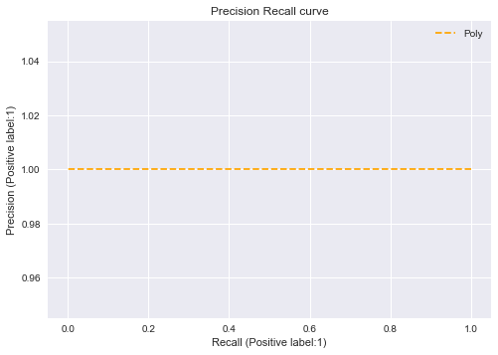

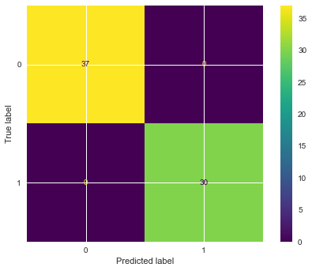 

1. Case 4



The model is 100.0% accurate

Pain = 0.7457749431413161%

No pain = 99.25422505685869%

The predicted image is : No pain

Accuracy poly: 1.0

Average precision-recall score: 1.0000

poly Accuracy : 1.0

poly Sensitivity : 1.0

poly Specificity : 1.0

F1 Score Poly: 1.000

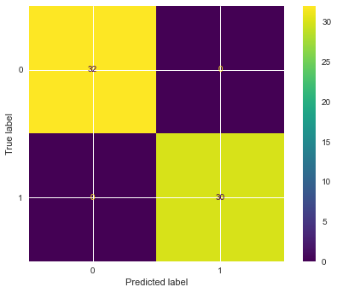  

1. Case 5

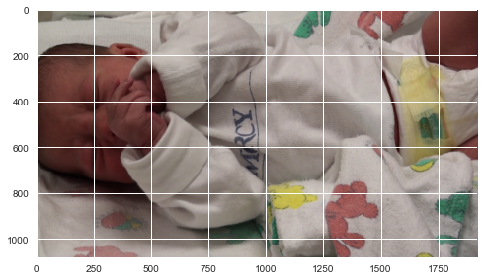

The model is 100.0% accurate

Pain = 14.95724697607716%

No pain = 85.04275302392284%

The predicted image is : No pain

Accuracy poly: 1.0

Average precision-recall score: 1.0000

poly Accuracy : 1.0

poly Sensitivity : 1.0

poly Specificity : 1.0

F1 Score Poly: 1.000



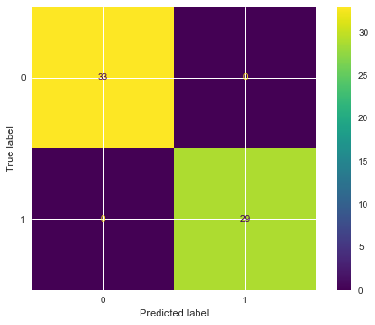



Cross Validation

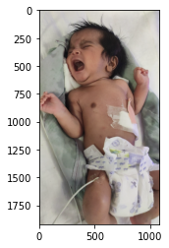

Pain = 56.094791350366926%

No pain = 43.90520864963307%

The predicted image is : Pain

Accuracy poly: 1.0

Average precision-recall score: 1.0000

poly Accuracy : 1.0

poly Sensitivity : 1.0

poly Specificity : 1.0

F1 Score Poly: 1.000 